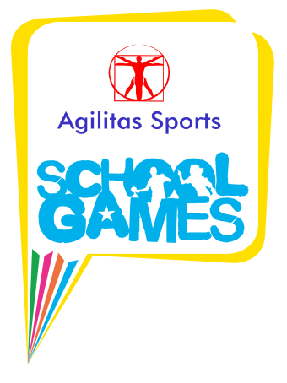

School Games News
Tuesday 11th February 2020 - Y8 Dodgeball
5 teams from The Priory School, The Deepings School, Bourne Grammar School and Kirkstone House came to The Priory in Spalding for a Academy for our annual Y8 Dodgeball competition.
Schools were encouraged to send along pupils who wouldn't normally be picked to represent their school in mainstream sports like football, netball, hockey etc and we wanted pupils with little or no previous experience of Dodgeball.
School Games Organiser Rupert Gibson explained that the aim of the day was for pupils to learn a new game, take part in a School Games event, represent their school and HAVE FUN!
The children had a warm up, learnt the rules of the game, played some practice matches and then all 5 teams played each other. They had some great games, with loads of close and exciting games. Bourne Grammar were won the most games just ahead of Kirkstone House but all teams showed lots of passion, determination and honesty.

